Benjamin Schwartz
SEEP Journal

10/3/05, 5th Grade: Solar System Tour
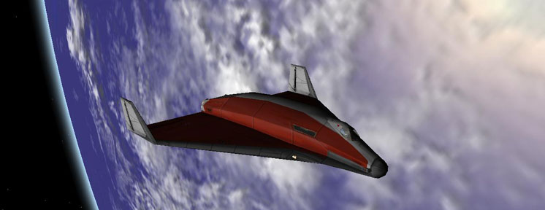
Today was my first lesson in Mrs. Clark’s class. We met in the school’s computer lab for a virtual tour of the Solar System. I wasn’t really sure what to expect, so I created a lesson that could be easily adjusted for whatever level the students were at. I ended up staying an extra half hour as the kids were surprisingly engaged by the tour. This is because, rather than holding up photos of planets and spewing off meaningless facts, I used Martin Schweiger’s spaceflight simulator Orbiter (screenshot above) to deliver an interactive presentation. The students were able to see the concepts I was talking about as I discussed them.
I began with a short pre-test to get the students thinking about space and see what their current ideas were. Then I launched into a five minute spiel about how NASA spinoffs affect their everyday lives using sports as an example. I told them that materials developed and improved by NASA for use in spaceflight helped make lighter, stronger, more flexible, more protective sports equipment. Should that equipment not be enough, they should be grateful for NASA spinoffs in medical technology. I gave a few other examples as well, such as firefighting equipment and flat panel TVs.
Then, I gave the students a few minutes at the computers and asked them each to find a few facts about one planet to present during the tour. Most students just listed statistics such as the length of the day, but I had expected this. I began the tour starting with Earth as a reference. I speed time up by a factor of 100. At this speed, 36 seconds is equivalent to an hour in the simulator; you can see the Earth spinning and the city lights turning on as day turns to night (or vice versa). It’s a pretty cool sight. We also took a quick gander at the Moon.
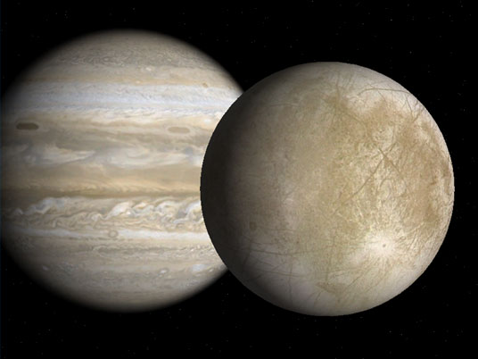
Then, it was off to Mercury. As she watched the image on the projector, a girl in the front row raised her hand and said “The planets spin, too?” I did a little touchdown dance in my head. I had chosen Orbiter for the purpose of showing the students things that still photos just can’t, like the cause of night and day. I confirmed that they did indeed spin, though all at different speeds. For each planet, students presented the facts they had found and I encouraged them to translate them into something meaningful, helping when necessary. In this way, the kids were able to understand the concepts being presented, which is much more meaningful then being able to spout off some numbers that don’t really mean anything to them.
We also compared and contrasted planets, which was an effective way to learn more about them. We stuck to basic characteristics such as the terrain, atmosphere, interesting features, and moons. This image is a screenshot from Orbiter of Europa with Jupiter in the background. When I showed this view in the class, one student said “Wow, that’s a big moon”. This was not surprising and easily correctable. As I zoomed out, the moon shrank quickly and other moons came into view while Jupiter’s apparent size did not change much. The relative size of Europa became clear as it was just one of several specs surrounding Jupiter.
The teacher eventually had to cut me off and the kids were disappointed that I had to leave. I would say that my lesson was a success. My goal had been to leave the students with more accurate ideas about the Solar System than if they had been taught using more conventional tools. I believe I accomplished this by using Orbiter to demonstrate the concepts I was attempting to convey and giving the students a good overview of the Solar System.
If I had the opportunity to do the lesson over again, I would reconsider my decision to have the students find facts about the planets. In retrospect, this did not contribute very much to the lesson and took much longer than I had anticipated. I think removing this totally and focusing more on comparing and contrasting the planets would be good. Any interesting or pertinent facts could be added by whoever was delivering the presentation.
Before I left, I gave the students Moon observation sheets to fill out nightly for the next three weeks. I plan to do a Moon lesson or two at that point in time.
10/4/05, 4th Grade: Water Cycle
In Mrs. Cliggot’s class we talked about the water cycle. I filled a vase with hot water and lit a candle under it. The students observed the steam rising from the container and we discussed different states of water. Then, I capped it with aluminum foil and placed ice on top. I knew it would take a few minutes for anything interesting to occur in the vase, so began talking about the water cycle.
I had originally planned on drawing the parts of the cycle on the blackboard. Fortunately, my lacking artistic skills were not called into action as the teacher had an excellent poster of Earth’s surface features. We discussed all the parts of the water cycle and even touched on how human interaction affected the water cycle.
During the discussion, it began raining in the vase. Everyone’s attention was called to the vase and I let the students watch it for a few seconds before I recalled their attention. When we completed our discussion of the water cycle, I returned to the vase. Students were able to identify how each part of the demonstration system correlated to a part of the water cycle.
This lesson was a complete success. I don’t think I would have changed too much about it.

10/10/05, Columbus Day
No school, right? I called a friend of mine in high school and he was in class! I figured it must just be a weird Texas thing, so I called my brother in Florida and he also had class. So I called the Brown School and nobody answered, so I figured they must not have class. Close call.

10/11/05, 4th Grade: Humidity and Hygrometers
With the weather basics down, we started talking about weather instruments and why measuring the weather is important. We started by talking about why humidity was important and how it affects us in our daily lives. I printed out information from USAToday for reference in case the students had questions I wasn’t prepared to answer, but ended up not needing it.
Then, we made hygrometers using milk cartons and rags. By comparing the temperature of a wet rag to the temperature of the surrounding air, a rough estimate of relative humidity can be obtained. I explained that the temperature difference is created by water evaporating off the wet rag carrying the heat away. A chart with the temperatures would give the relative humidity, but the students were unfamiliar with reading such a chart, so I explained it to them. Most understood quickly, but a few needed additional help. After some chart-reading practice, we returned to the hygrometers. I asked the students questions to ensure they understood the principles behind the hygrometer and they did. Overall, this lesson went really well. The students understood humidity and how it affects us and also got some math in with the chart.

10/17/05, 5th Grade: Scale Model Solar System
It is almost impossible to fathom our place in the Universe. Fortunately, there are a couple of tools to help. I started by playing the video “Powers of Ten” (http://www.powersof10.com/). This short film by Charles and Ray Eames will humble even the largest of egos as it shows the “relative size of things in the Universe and the effect of adding another zero”. It starts with a small picnic on the shore of Lake Michigan and zooms out. The rate of zoom accelerates until you’re speeding through the cosmos to the edge of space—the far edge. Then, you’re rocketed back towards the Milky Way, the Solar System, Earth, North America, Chicago, and the picnic which you’ve forgotten about at that point. The video continues to zoom in, all the way down to the subatomic particles of the sleeping picnicker’s hand. After the video, I explained what powers of ten are and the accelerating rate of zoom. Though the video explains this, I wanted to ensure the students understood.
Then, we took a trip outside to make a scale model Solar System. I used “If the Sun was a Grapefruit” which I borrowed from Professor Waller. In this model, the Sun is a grapefruit (actually, a plastic basketball about the same size). Earth is a poppy seed 11 meters away. Jupiter, the largest planet, is a blueberry. We got as far as Saturn before we ran out of room. While our Solar System was spread out, I pointed out some of the difficulties of space travel. Imagine trying to land an atom on a particular area of grain of salt 16 meters away and you’ll have an idea of the challenges just getting to Mars. I explained that the nearest star to our Sun was Alpha Centuri, which would have been in Denver, Colorado. Denver isn’t all that far away in our connected world until you point out that the Earth is a mere poppy seed in this model.
It’s extremely hard to imagine things on such a large scale, but I think this lesson is the best way to attempt to convey cosmic distances.

10/18/05, 4th Grade: Weather Instruments
Part of the 4th grade curriculum involves studying meteorology and making “classical” weather instruments to understand the principles involved. We started this last week with the hygrometers. I started this class by demonstrating a hair hygrometer I had made (it was more humid in the classroom than in my house and less humid outside). We also talked about weather vanes and rain collectors. We made a barometer and discussed atmospheric pressure. We also talked about different types of fronts and how studying them can help predict weather.
I haven’t mentioned it before, but the kids always ask lots of questions at the end of class. Many times, they’re trying to keep me from leaving so they don’t have to go back to work. Sometimes, they ask really good questions such as asking about water vapor and rainbows. It’s hard to deal with because I want to answer them, but don’t have the time to answer properly and it would take away from a future lesson. The toughest questions to deal with are from the fifth grade because they’re most interested in stuff like black holes, which we don’t know much about.

10/24/05, 5th Grade: Luna—Correction: Going to the Bathroom in Space
Today we were supposed to talk about the Moon because the students were supposed to have completed their lunar observation calendars. Unfortunately, their weather for most of the month was lousy for looking at anything but grey. Instead we talked about going to the bathroom in space.
The class was actually about leaving and working in space, but the lesson is so named because using the restroom is actually one of the biggest challenges in space. This is a lesson I have both experienced and given before and it is very fun for everyone involved. I started with the reason why the disposable diaper was invented: Alan Shepard on the flight of Mercury 3. In a nut shell, Al had a big breakfast (lots of OJ and coffee for energy), was stuck on the pad for hours and hours while they worked out the kinks, and eventually was forced to relieve himself in his space suit while the scientists mumble “I knew we forgot something.” Since he was in the rocket lying on his back, that’s where all the urine went. Yep, the first American in space did so with a very wet (and probably smelly) backside.
Scientists came up with a pretty neat solution, though, a polymer called sodium polyacrylate that can absorb 200-300 times its own weight in tap water and hold it in a gel form. I demonstrated by putting a teaspoon of the substance in a jar and adding water. While waiting for it to gel up, I showed the students the diaper I dissected to get the crystals and explained that diapers are still worn by astronauts today. Then, I passed the jar around so the students could see the gel and warn them not to eat it (it’s non-toxic, but I’m sure you could imagine that you have to drink a lot of water to flush it out).
Then I talked about the Space Shuttle and Space Station. I talked about the challenges of supporting life in the desolation of space. Of course, part of this involves going to the bathroom and there are two great stories about zero-G toilet misadventures. At one point, the kids got a little bit out of line, but they quickly settled down when I told them that I wouldn’t finish the story if they weren’t mature enough to handle it.
This lesson went very well. I was worried that the kids would start misbehaving during some of the stories, but it didn’t really become a huge issue.

10/25/05, 4th Grade: Wild Weather
We picked up where we had left off last week, with fronts. To demonstrate how a cold front slips under a warm front, I used a lesson from the student’s textbook. I prepared a bucket of cold blue water and warm red water and a container with a divider in the middle. At the same time, Mrs. Cliggot and I poured each bucket into the container and then removed the divider. The water promptly… mixed into purple. While some mixing in the middle had been expected, this was almost totally mixed. There was a small difference in color between the top and bottom and we used that to talk about warm and cold fronts. While it wasn’t really a success, it wasn’t a total failure, either.
We talked about storms as well. I demonstrated a tornado in a jar which I had created and the kids liked that.

10/31/05, 5th Grade: Gravity
I started with a quick pre-test about gravity. The students answered as expected. They understood a little bit, but there were many misconceptions. One student in the class is extremely bright and he aced it. Even I didn’t get every question right the first time I took it and I was shocked that this 5th grader understood so much.
For this lesson, I was unable to find or create a good demonstration or activity (though I did drop a textbook to prove that gravity was working). I basically talked about gravity for a while, using the kids’ questions as a guide to what they didn’t understand. One of the biggest challenges was explaining that there is no up or down in space. Something floating in space is just floating and things fall towards the center of a large mass, not to some celestial ground. This is the hardest thing to convey and I can’t think of any way to demonstrate this.
Tonight, some students from the school came trick-or-treating at my place, which gave me the chance to meet some parents. It was a little bit awkward, but I think I made a good impression. The students had obviously told their parents a lot about me.
Added Dec. 2: Claudine Kavanaugh, a Tufts PhD student and Museum of Science interpreter showed me some good gravity/mass demonstrations. One involves comparing the fall of two tennis balls, one filled with pennies. The other is a great demonstration of mass involving two sheets of paper and how mass changes when paper is crumpled.

11/1/05, 4th Grade: Weather Maps
Mrs. Cliggot asked me to teach about weather maps today because a meteorologist is coming tomorrow and she wanted the students to be familiar with how weather maps work. I planned a lesson that I thought would be fun for the students, but it did not go very well at all. It was raining, so the students had an indoor recess and they were very restless when I arrived (towards the end of the day). On top of that, there was a substitute teacher who was somewhat less than helpful.
Before class, I printed out a variety of different weather maps. I handed them out and asked the students to work in groups study them and try to figure out what they showed. I also asked them to prepare to give a weather report to their class based on their map. I walked around the class and the students told me what their maps showed. I corrected them when necessary, but they understood pretty well.
Students came up and presented their weather reports. This is where things totally fell apart. Nobody paid attention or was at all interested. The only thing the substitute offered me was “I think an hour is too long for this age, they don’t have the attention span.” Oh, well, you can’t win them all.

11/2/05, 4th and 5th Grade: Meteorologist
Joe Venuti, a meteorologist for WLVI-TV (Boston’s WB) came to the school to talk about weather. He was very good at talking to the kids and he brought some cool demonstrations. One demonstration was of a tornado in a jar, which I had already done with Mrs. Cliggot’s class. This made me feel good as I thought it lent me some credibility.

11/7/05, 5th Grade: How Do We Know the Earth is Round?
Carl Sagan explained this really well on Cosmos, so I tried to do my lesson in a similar fashion. I made a map of Egypt on foam board and installed pencil “towers” in Alexandria and Syene. Eratosthenes actually calculated pretty accurately the polar circumference of the Earth based on the shadows of buildings in these cities in 230 B.C.E. I used the shadows in my model to demonstrate the principles Eratosthenes used in his calculations. I also talked about ships disappearing over the horizon and the shape of Earth’s shadow during a lunar eclipse.
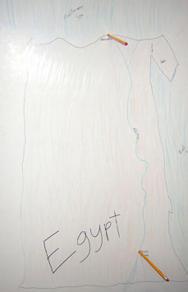
My demonstration did not go as well as Carl Sagan’s, though. I’m not sure why, but I left the classroom feeling that I had not done well getting the concept across. Even with a solid activity, teaching is very, very hard to do. Asking the right questions and explaining things well to make the activity into real learning is not easy and much require a lot of practice.

11/8/05, 4th Grade: Wild Weather Notes
There wasn’t too much more to say about weather, but the kids were still really interested in it. Today, we introduced a new skill: note taking. The students were given outline forms and could pick a type of weather and take notes about it using the books in the classroom. It was a nice break from having to prepare a lesson before class.

11/14/05, 5th Grade: Solar System Formation
I found a lesson about Solar System Formation for a college-level introductory astronomy course. It involved giving each student a part as particular type of scientist and the information they needed to assume the role. Then, the students walked around and talked to other students, gathering information about the Solar System with the goal of figuring out how it was formed.
Some of the concepts in the activity were a little too complex, so I simplified it for a 5th grade level. The students enjoyed it a lot and finished in the perfect about of time, too. This lesson went really well.

11/15/05, 4th Grade: Solar Collectors
I printed out some information on the principles behind solar cooking which we read in class. Then, we set the students loose on a huge pile of materials and they started building. I had some design examples available for the students, but they preferred to use their own imaginations. Mrs. Cliggot and I walked around checking the designs and asking questions and giving advice when requested. The students were really excited.

11/21/05, 5th Grade: Why Does the Sun Shine?
I borrowed a solar telescope from the Tufts Astrophysics department. I set it up outside the school and the students all came out and observed the sun. Though the sun was not very active, there was a sun spot about the size of Earth and some small prominences visible. The 4th graders also got to observe.
Back in the classroom, we talked about the Sun. Since the formation of the Sun was an important part of the formation of the Solar System lesson, we already had a head start.

11/22/05, 4th Grade: Solar Collectors
It was cloudy out, so testing the solar collectors was a no-go, which was fine since the students wanted more time to work on them. We also had them sketch and label their collectors and make predictions.
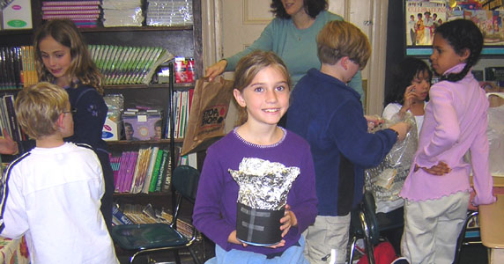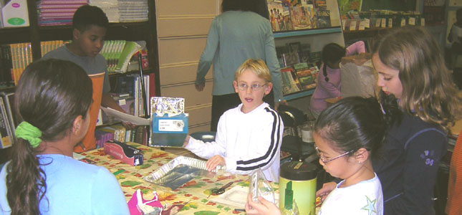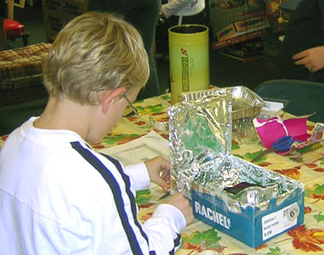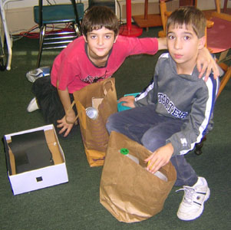

11/28/05, 5th Grade: Moon Phases
The students were supposed to observe the Moon everyday for the past few weeks and bring in their observation sheets today. I don’t know what happened, but only two students had them and the teacher was absent, so I was on my own. I learned that the students were already familiar with the phases, anyway, so I skipped discussing the observation sheets and jumped right into the cause of lunar phases.
Each student received an orange which the lunch aide had graciously provided me. I closed the window shades, turned off the lights, and turned on the overhead projector. I asked the students to spread out in the open area in the back of the room and faced the projector in that direction. I stood with the students and asked them to hold their orange up as I did. The students correctly identified the phase of their orange as waning gibbous. I asked the students to slowly turn in a full circle and they saw the Moon’s whole cycle right on their orange. We also were able to demonstrate eclipses. I continued asking questions to ensure the students understood the cause of lunar phases.
The phases of the Moon are extremely tough to teach because it’s hard to create a mental Earth-Moon-Sun model and typical classroom models are greatly lacking. By putting the students in the model, they are able to conceptualize the causes of the Moon’s phases better.

11/29/05, 4th Grade: Solar Collector Testing
It was partly cloudy today, not the best conditions for solar cooking. I pulled up an animated cloud map on the computer in the classroom and showed them the cloud activity. The winds were blowing from the south and it looked like their might be a good gap in the clouds arriving soon. The students were able to see weather maps being used in a real-world situation (one that affected them, no less).
While we waited for our window, everyone showed off their collectors. We also made charts to record the data. When the window opened, we went outside. The Sun was low in the sky and conditions weren’t great, but they looked to be the best we were going to get and some heating was experienced. Mrs. Cliggot said she may try again if conditions were better during the week.

