Space Science Education Journal
Benjamin Schwartz

9/15/05, Noon – Science Education

Today, I experienced first-hand many of the concepts we have been discussing in class. From the deficient education system to the rigors of teaching science, I have discovered why correcting our nation’s science classes is so important.
Our lacking education system really hit home today as I watched the videos A Private Universe and Minds of Our Own. I previously thought that I had a decent education, that I understood the basic workings of our world. I learned photosynthesis in grade school and I believed it was an easy concept. I realized while watching the videos that, like John in the video and the Harvard grads, I could easily rattle off the equation for photosynthesis, but I had no idea what actually made up the tree. When the interviewer said “carbon,” it clicked. It made perfect sense to me all of a sudden: the plant inhales CO₂, the carbon goes into the plant and the oxygen was exhaled. Then I decided to look for more information on the Internet and I discovered that the O₂ was actually created from the water, not the carbon dioxide. All of a sudden, this simple concept that I had a great understanding of was extremely confusing. It was a startling realization; I felt like all of my education so far was worthless.
I also learned how difficult it can be to teach science, especially a subject such as space science. Teaching in general requires patience and understanding. It is easy to move too quickly, leaving students with an incomplete understanding of the subject, frustrating them to the point that they may lose interest. Space science is even more difficult because of the scale of ideas being presented and because students are unable to directly observe the concepts from varying perspectives. When learning about plants, for example, students can directly observe every part of the plant and how it fits into the whole of the plant and surrounding environment. When teaching about the Moon, students can observe the Moon in the sky and observe changes in its appearance and position in the sky, but it is hard to comprehend these changes in terms of the solar system or the “god’s-eye-view”. I watched the DVD with my girlfriend. When she paused the video and asked me to explain the phases of the Moon, I first turned to the Internet and found a Java applet (http://www.astro.wisc.edu/~dolan/java/MoonPhase.html) that showed a view of the Earth and Moon from above alongside a display of the face/phase of the Moon. This method was only marginally better than the traditional static textbook image… it was confusing and frustrating to both of us. Then, I tried an impromptu demonstration using the computer screen as the Sun and our fists as our own personal Moons. This got the point across much better. However, when I tried to relate the demonstration to the Java applet for a complete solar-scale understanding, the frustration and confusion returned. I decided to leave the subject for the time being and attempt to work out a good method for relating this another time. Without an excellent ability to visualize spatial concepts, relating a model of the solar system to what we see in the sky is a difficult challenge.
There are huge gaps in the way we teach science and I learned today how important it is to correct these issues in our educational system. I feel like I have been cheated and I want future generations to really learn and have a deeper understanding of scientific concepts so that they can learn and discover all of the great things science has to offer. As part of this, I have signed up for a course offered by the Experimental College called SEEP, Science Elementary Education Partners. This course will allow me to spend 2-3 hours a week in a fifth grade classroom where I hope to be able to apply and evaluate the concepts we discuss in this class. I hope my children will have a more valuable K-12 educational experience than I did.

9/18/05, 10:00 P.M. – Harvest Moon

I went out on my roof this evening and looked at the Harvest Moon, so called because it rises as the sun sets, and is bright enough the allow farmers to see late into the night in order to keep working on their autumn harvest. The actual harvest moon occurred yesterday evening, but it would have been useless for any Boston-area farmers due to the overcast skies.
Using my naked eyes to observe the Moon did not work very well. Though I was able to make out some details, my pupils dilated to adjust to the dark and the bright Moon looked washed out. I brought out my small binoculars (10x25); these were much better. I could focus easily on the Moon and see surface features in detail. Unfortunately, my telescope (Meade 70mm refractor) and large binoculars were left in Florida. Both are excellent for picking up a great deal of Lunar detail.

9/19/05, 9:00 P.M. – Horizon Moon

I went out on my roof again to look at the Moon. I had some trouble finding it, but then I saw it through the leaves of a tree. It was large and orange. I knew that the Moon appeared orange because of the atmosphere, similar to the way the Sun appears orange when it is low in the sky. I also knew from previous research that the Moon’s apparent size was just an illusion, but I had never found a satisfactory explanation for it. It is also interesting to note that this “Moon Illusion” also affects the sun when it is low in the sky. Science@NASA offers two possible explanations. One theory is that the Moon set against foreground objects causes you to think the Moon should be much larger. This is known as The Ponzo Illusion. However, airline pilots with nothing in between themselves and the Moon experience the same illusion, so this does not really apply here.
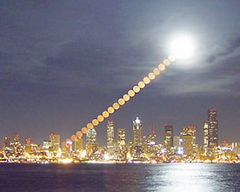
Another explanation is that the way we perceive the sky is responsible. We observe birds and planes flying on a daily basis. When overhead, they are nearer and appear larger. When far off into the horizon, they are farther and appear smaller. Our brains, used to these variations, miscalculate the Moon’s true distance and size. This theory does not make very much sense to me. A bird or plane in the distance is not resized by our brain, why should the Moon be?
While researching the Moon Illusion, I found examples of several other misleading diagrams. The Moon is very complicated and many attempts to simplify concepts ends up making them even more confusing. I did learn that you can make the Moon Illusion disappear bending over backwards and viewing it upside down. It is also possible to make the illusion disappear by viewing it through a narrow opening or crossing your eyes, though I have not had the opportunity to try either of these myself yet.
In my research, I found many competing theories, but not one that seemed plausible or fully explained enough to satisfy me. The problem of the Moon Illusion still stands for both me and many other researchers.

Sources:
http://science.nasa.gov/headlines/y2005/20jun_moonillusion.htm.
http://facstaff.uww.edu/mccreadd/
http://unmuseum.mus.pa.us/exmoon.htm
http://www.lhup.edu/~dsimanek/3d/moonillu.htm
http://www.griffithobs.org/IPSMoonIllus.html

9/22/05, 7:00 P.M. – September Equinox

I went outside an observed the Sun at today. I looked at the Sun for a few seconds at a time using dark welder’s glass which I had previously purchased and used to observe an eclipse. The Sun was in the southeast sky at noon and due south about forty minutes later. The Sun was southwest at 3:00 and set just about due west at about 6:30. If it were not for the atmosphere, today would have 12 hours of daylight and 12 hours of darkness, however the refractive tendencies of the atmosphere delay this for three or four days. Today is the September Equinox, marking the beginning of Fall here in the Northern Hemisphere. In areas south of the equator, Spring has started. The Earth has tilted so that the Sun has moved from the Northern Celestial Hemisphere to the Southern Hemisphere. Right now, it is just about at the Celestial Equator, providing equal sunlight to the Northern and Southern Hemisphere, as can been seen in the following map/satellite image from 1:30 p.m. (note hurricane Rita in the Gulf of Mexico).
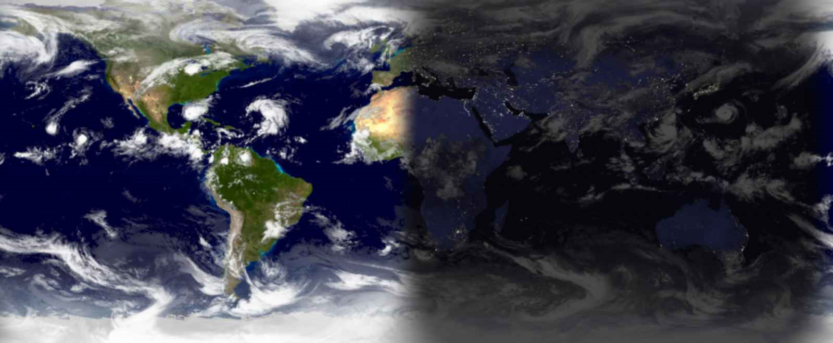
Map from http://www.die.net/earth/

9/24/05, 7:00 P.M. – Observing the Sun and Earth’s Tilt
For my observation entries, I plan to observe the Sun and how its position in the sky changes throughout the season. I will also observe how the sunlight is distributed over the Earth using this Mercator projection from die.net. I know, of course, that I can expect the Sun to appear further south and lower in the sky as our high latitude tilts away from the Sun and I also know how the sunlight will curve on the sunlight map. What I don’t know and am looking forward to is observing how quickly these will occur. This is also the first time I’ll be living so far north, so I don’t know how low in the sky the Sun will actually be.

Today’s Sun Observation: At 12:30 today, the Sun was about 45 degrees above the south horizon. It set due west at about 6:30.
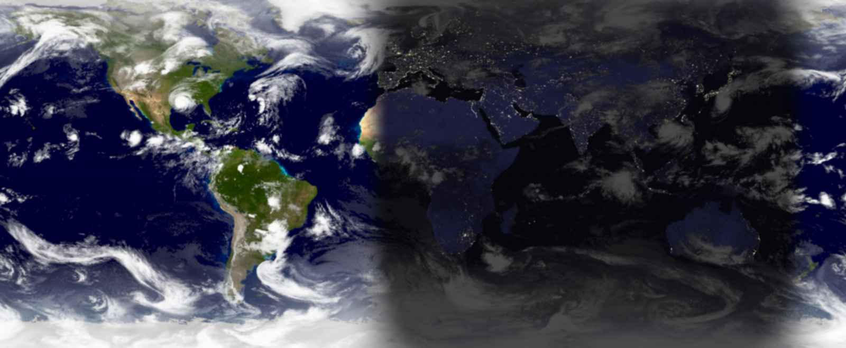

9/27/05, 9:00 P.M. – NASA Administrator: Space Shuttle was a Mistake
NASA Chief Michael Griffin thinks NASA went in the wrong direction when they chose to cancel the Apollo program in favor of the Space Shuttle and Space Station, according to USA Today. I couldn’t agree more. The Space Shuttle and Space Station programs have almost always been behind schedule, over budget and generally not as useful as originally planned; In short, they are the products of a bureaucratic space agency. Griffin wants to lead NASA in a better direction, but I can’t help thinking that it might be too late. Commercial spaceflight ventures are ramping up and may soon eclipse NASA. Elon Musk’s SpaceX already has a launch manifest containing several U.S. government and international private customers and may soon compete directly with Boeing’s Delta 4 and Lockheed Martin’s Atlas 5 rockets, according to Space.com. Virgin Galactic has licensed SpaceShipOne’s technology, making them the forerunner in commercial manned spaceflight. With these advances, I can’t help but wonder how long it will be until NASA, at least as we know it, becomes obsolete.

Today’s Sun Observation: At 11:20 this morning, the Sun was about 40 degrees above the south-south east horizon. At 12:30 it was 45 degrees above south. It set in the west at about 6:40.
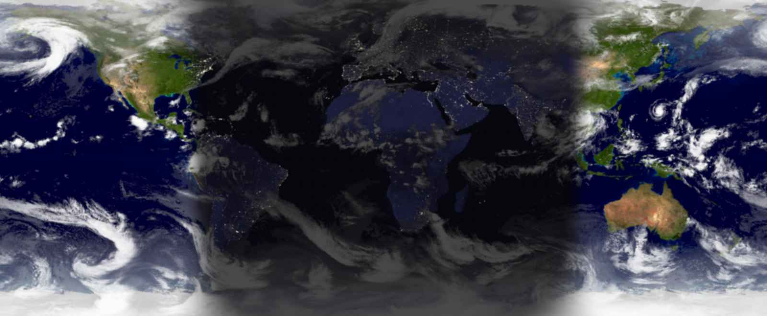

9/29/05, 4:00 P.M. – Sun Observation
I love rain. I hate clouds. Unfortunately, they’re mutually exclusive. Today, the Sun (my astronomy software promises) was almost exactly 45 degrees above south at 12:35 p.m. The curve of the sunlight on the Mercator projection appears to have changed quite a bit over the last two days.
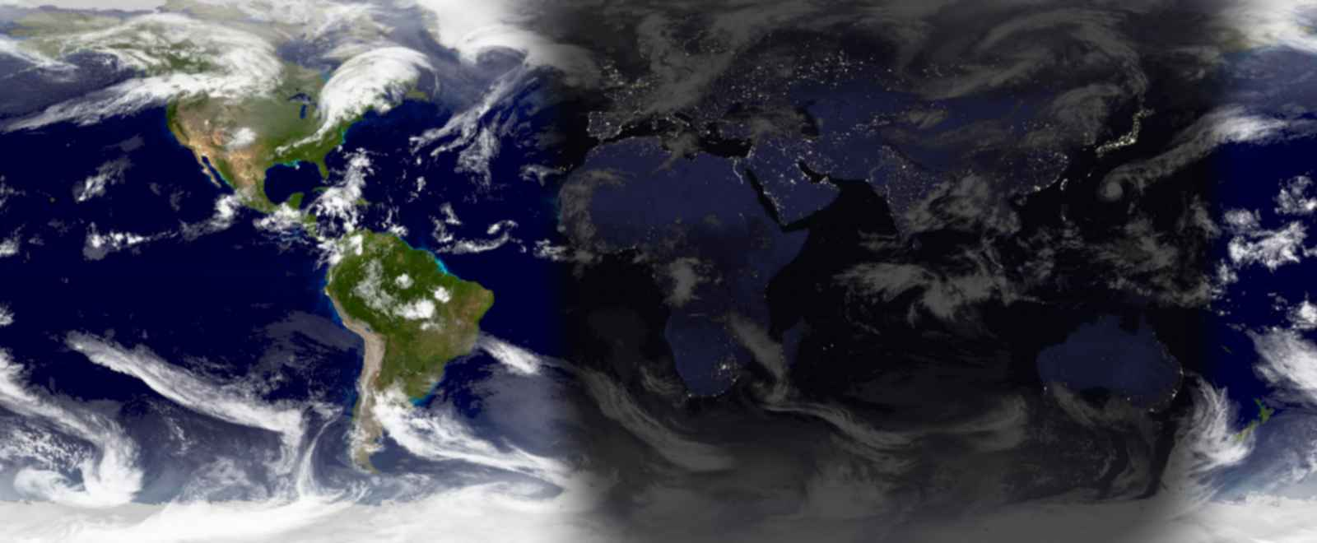

10/1/05, 1:00 P.M. – Sun Observation
Based on its position two days ago, I observed the Sun when it was due south, at 12:35 today. I estimated it to be 45 degrees above south. TheSky Astronomy Software tells me that it was actually 44°14'23" (+44°15'24" with refraction).
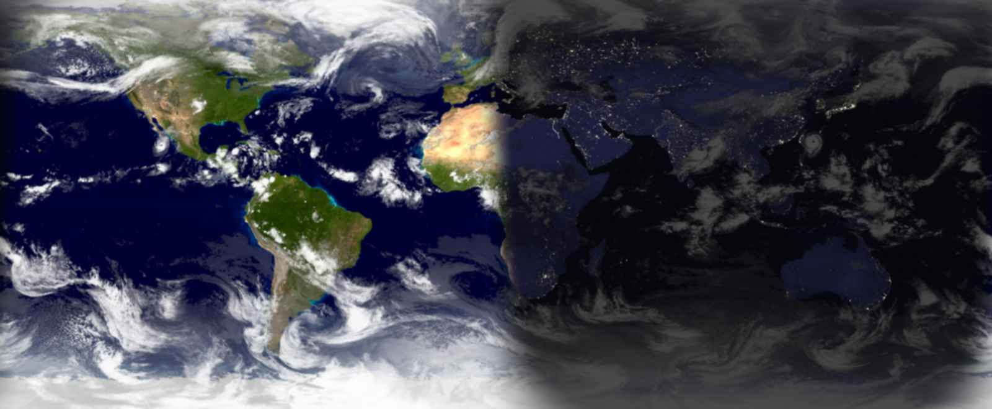

10/4/05, 4:30 P.M. – Teaching about Space: Orbiter Solar System Tour
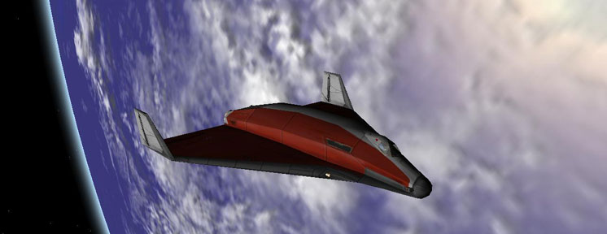
Yesterday, I spent an hour and a half in a 5th grade classroom teaching about the Solar System. I expected the kids to lose interest after a few minutes, but I ended up staying an extra half hour as they were surprisingly engaged by my virtual tour. Rather than holding up photos of planets and spewing off meaningless facts, I used Martin Schweiger’s spaceflight simulator Orbiter (screenshot above) to deliver an interactive presentation. The students were able to see the concepts I was talking about as I discussed them.
I began with a short pre-test to get the students thinking about space and see what their current ideas were. Then I launched into a five minute schpiel about how NASA spinoffs affect their everyday lives using sports as an example. I told them that materials developed and improved by NASA for use in spaceflight helped make lighter, stronger, more flexible, more protective sports equipment. Should that equipment not be enough, they should be grateful for NASA spinoffs in medical technology. I gave a few other examples as well, such as firefighting equipment and flat panel TVs.
Then, I gave the students a few minutes in the computer lab and asked them each to find a few facts about one planet to present during the tour. Most students just listed statistics such as the length of the day, but I had expected this. I began the tour starting with Earth as a reference. I sped up time by a factor of 100. At this speed, 36 seconds is equivalent to an hour in the simulator; you can see the Earth spinning and the city lights turning on as day turns to night (or vice versa). It’s a pretty cool sight. We also took a quick gander at the Moon.
Then, it was off to Mercury. As she watched the image on the projector, a girl in the front row raised her hand and said “The planets spin, too?” I did a little touchdown dance in my head. I had chosen Orbiter for the purpose of showing the students things that still photos just can’t, like the cause of night and day. I confirmed that they did indeed spin, though all at different speeds. For each planet, students presented the facts they had found and I encouraged them to translate them into something meaningful, helping when necessary. In this way, the kids were able to understand the concepts being presented, which is much more meaningful then being able to spout off some numbers that don’t really mean anything to them.
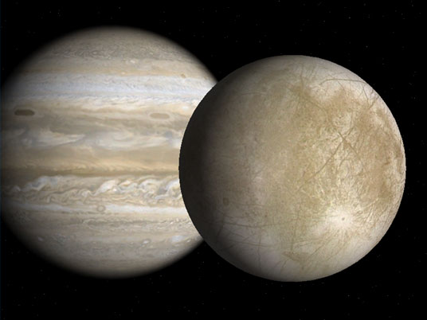
We also compared and contrasted planets, which was an effective way to learn more about them. We stuck to basic characteristics such as the terrain, atmosphere, interesting features, and moons. This image is a screenshot from Orbiter of Europa with Jupiter in the background. When I showed this view in the class, one student said “Wow, that’s a big moon”. This was not surprising and easily correctable. As I zoomed out, the moon shrank quickly and other moons came into view while Jupiter’s apparent size did not change much. The relative size of Europa became clear as it was just one of several specks surrounding Jupiter.
The teacher eventually had to cut me off and the kids were disappointed that I had to leave. I would say that my lesson was a success. My goal had been to leave the students with more accurate ideas about the Solar System than if they had been taught using more conventional tools. I believe I accomplished this by using Orbiter to demonstrate the concepts I was attempting to convey.

Today’s Sun Observation: At 12:35, I estimated the Sun to be at 45 degrees above south. I know that it is actually slightly lower and TheSky confirms that it was actually at 43°04'41" (43°05'44" with refraction). I also found out that transit actually occurred at 12:32 p.m., at which point the Sun’s altitude was 43°04'52" (43°05'55" with refraction). All these numbers make me want to organize this data in a chart, so I think I’ll create one at the end of this document.
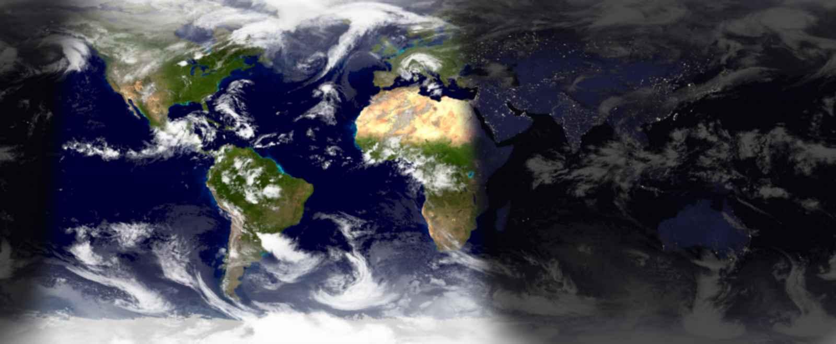

10/12/05, 12:30 P.M. – Unending Clouds: The Arch-Enemy of the Astronomical Observer
It’s been pretty dreary out the past couple of weeks; I had given the students in the fifth grade class Moon observation logs, but with this weather, we might have to try it again next Lunar cycle. By that time daylight savings time will be in effect and it will get dark earlier, so the kids will be able to observer better. I use the astronomy software now to tell you that the Sun is currently about 40 degrees above south and will set at 6:06 p.m. just south of west.
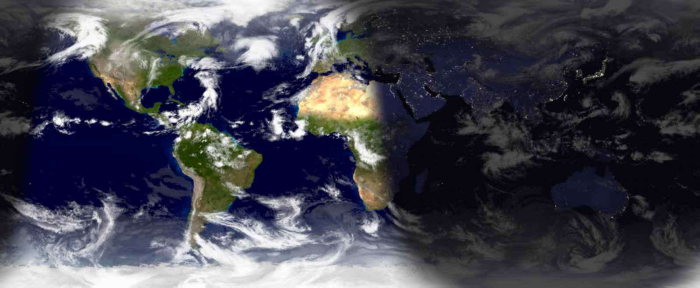

10/16/05, 7:30 P.M. – The AAVSO
After an hour on public transportation and thoroughly soaked from walking in the rain, I arrived at the AAVSO public workshop. I had never really heard of variable star observing, but it turns out to be pretty cool. VSOers are amateur astronomers who observe variable stars such as TU Cassiopeiae to provide data for professional astronomers. Apparently it’s a pretty addicting way to help real science. Observing variable stars is pretty cool, but I don’t think it’s something I could really get into.

Today’s Sun observation is brought to you by TheSky Astronomy Software: Transit occurred at 12:29, at which point the Sun was 38°33' above south. It set at 6:00 slightly south of west, what you might call WWSW.
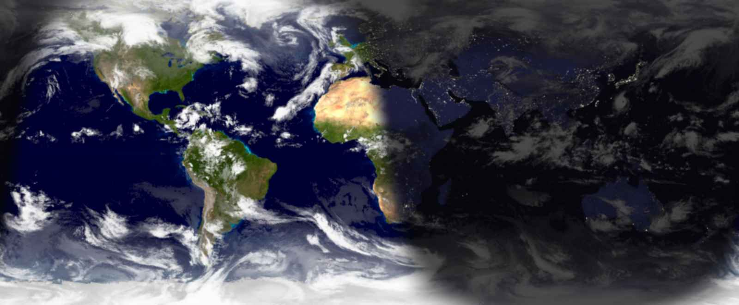

10/19/05, 12:29 P.M. – Space Science Education Report
For my first report, I am writing about misconceptions perpetuated by popular media such as movies, TV shows, and even news reports. My paper will probably pale in comparison to Mike’s Stellar Evolution lesson plan and Seamus’ peer-instruction review, but it should be interesting none the less. I had a few other ideas for the paper, but I decided on this subject because I am more familiar with it and I already had many resources to use.

Today’s Sun Observation: The dismal weather continues. Hurricane Wilma is now in the Gulf. The Sun, you ask? I wonder if there still is a Sun behind all those clouds! If there is, it would be 37°27' above south right now and would set at 5:55, five minutes earlier than it set three days ago.

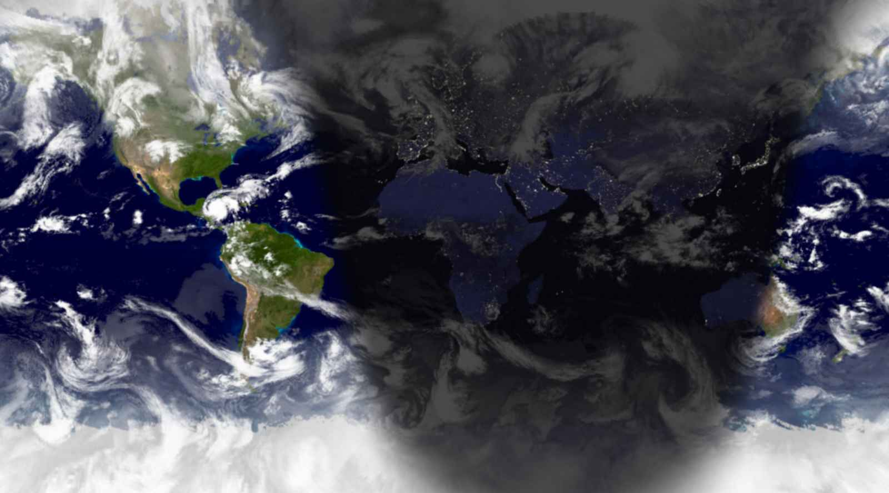

10/22/05, 5:00 P.M. – Sun Observation
It’s raining. Surprised? Me, neither, just look at that satellite cloud cover image! The Sun was 36°23' when transit occurred at 12:28. It’s currently about 8 degrees above west-southwest and preparing to set in about 50 minutes.
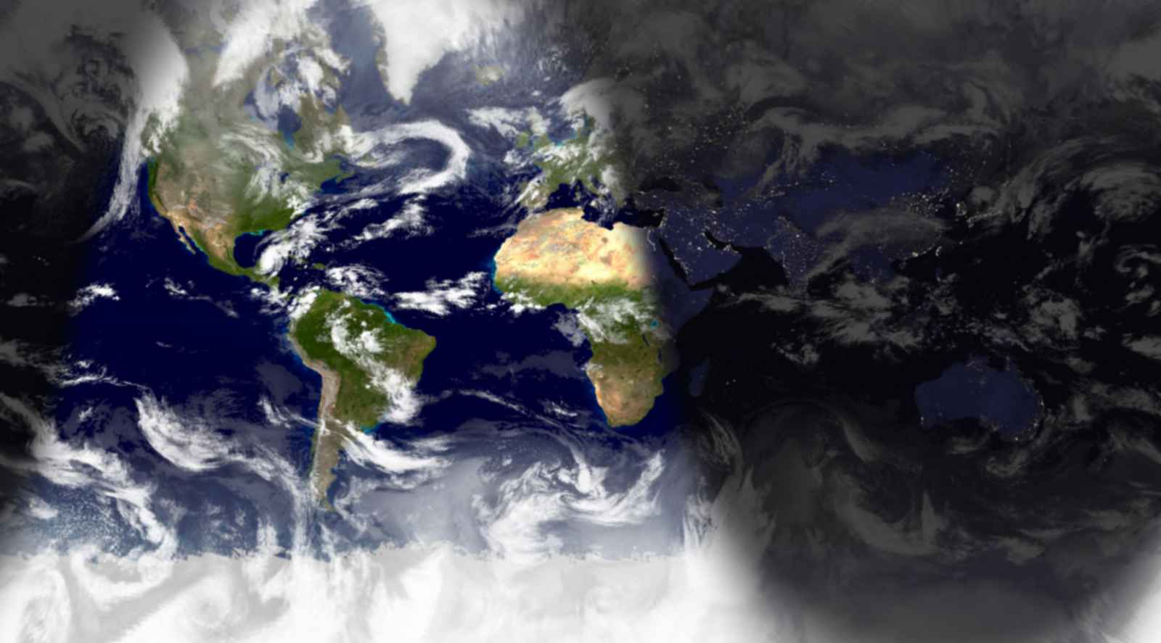

10/26/05, 5:00 P.M. – Hurricane Season
Hurricane Wilma arrived yesterday. Today’s Sign of the Apocalypse: It’s not even November and we’ve already depleted the entire list of names. Next, we’ll have to start using the Greek alphabet (I can’t wait for Hurricane ΣΧ).
Since it’s been pretty overcast, today’s observation is once again from my PC, which informs me that transit occurred at 12:28, at which point the Sun was 35 degrees above south. It will set at 5:45.
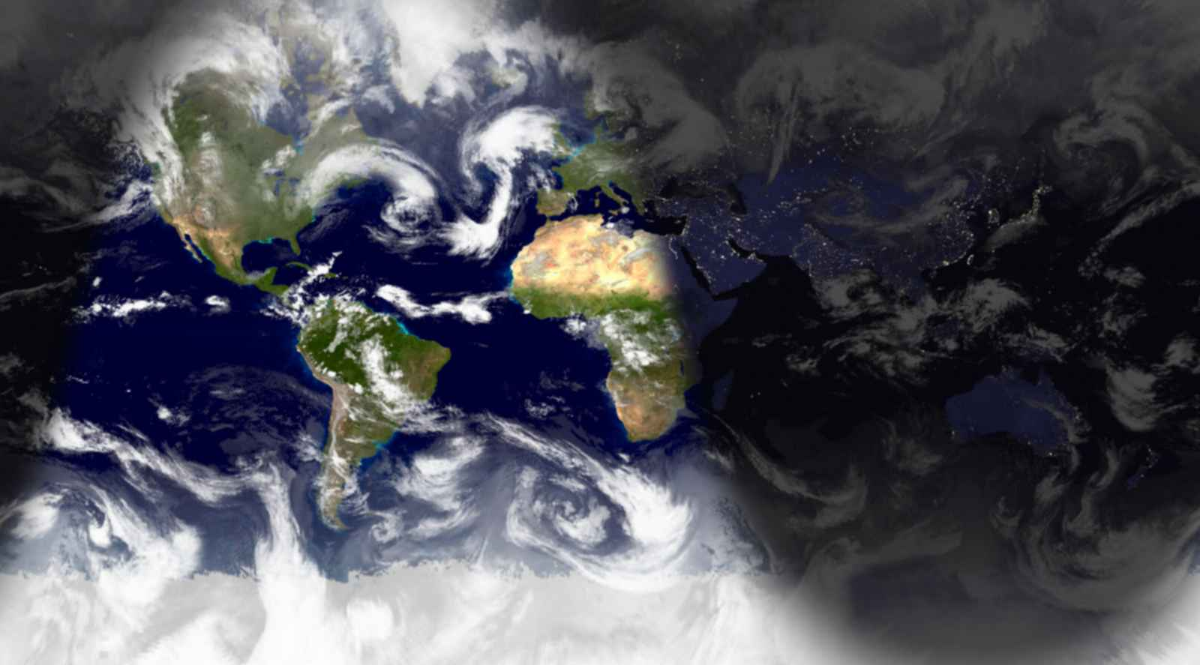

10/27/05, 1:00 P.M. – Sun Observation
The Sun has been getting lower in the sky and setting sooner very quickly, faster than I would have imagined. This will continue until the Winter solstice on December 21, the day with the least sunlight. The short days of winter supposedly cause depression for many people. I hope I can avoid that!
Today continued the trend of mostly cloudy. Had the Sun been visible, it would have been highest in the sky at 34°40'35" at 12:28, about 60' lower than at the same time yesterday. It will set at 5:54, a minute earlier than yesterday.
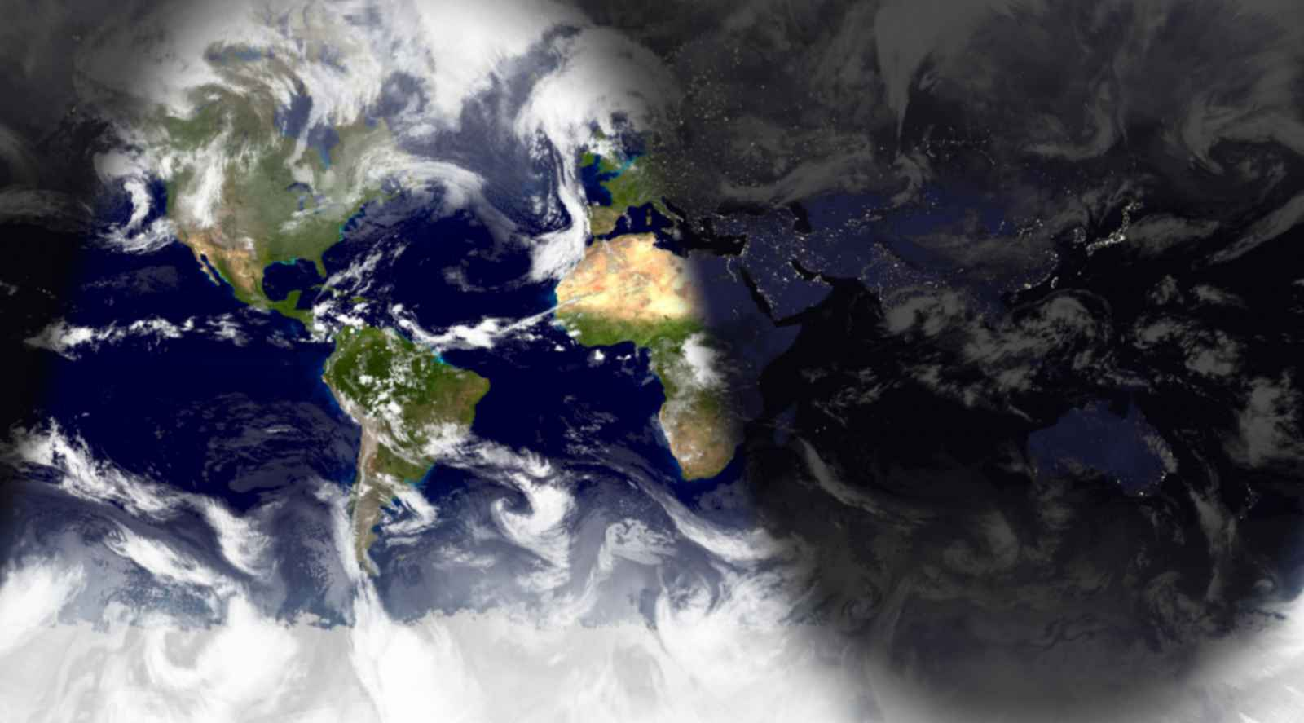

11/2/05, 12:00 P.M. – Sun Observation
Transit: 11:27 a.m., +32°43'19" (with refraction: +32°44'51")
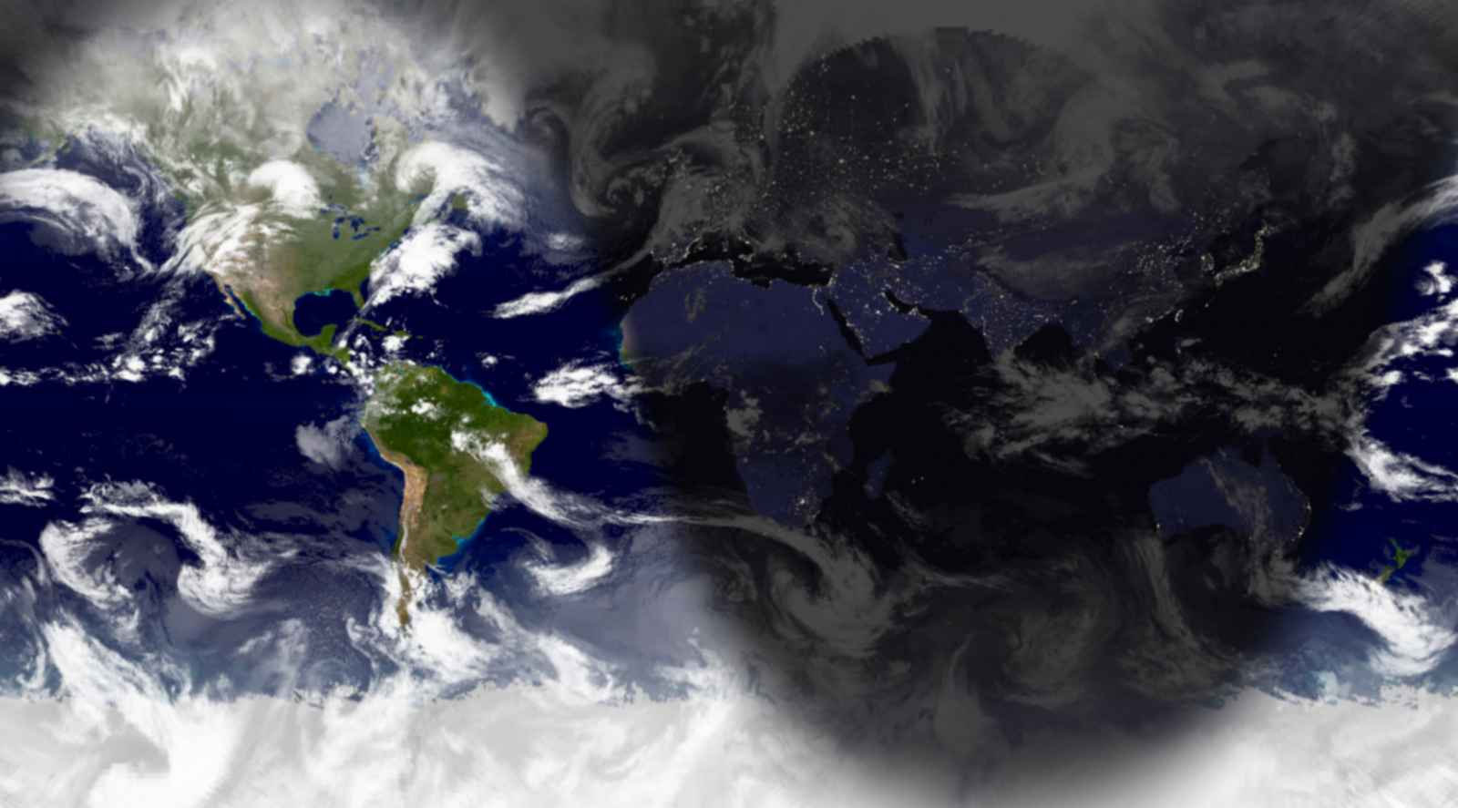

11/6/05, 10:00 P.M. – Observing at MOS
I went to the Museum of Science on Friday to look through their telescope. It was looking good for observing, but clouds started encroaching at about 8:15. Though I was first in line, I allowed others to look so that as many people could see it before the clouds ended the session. A dozen or so people got the chance before the event was finally called off. These darn clouds must have it in for us.

Today’s Sun Observation: Transit occurred at 11:27, the Sun was 31 degrees above south. It’s been at the same time for a quite a while now and will start to occur later now.
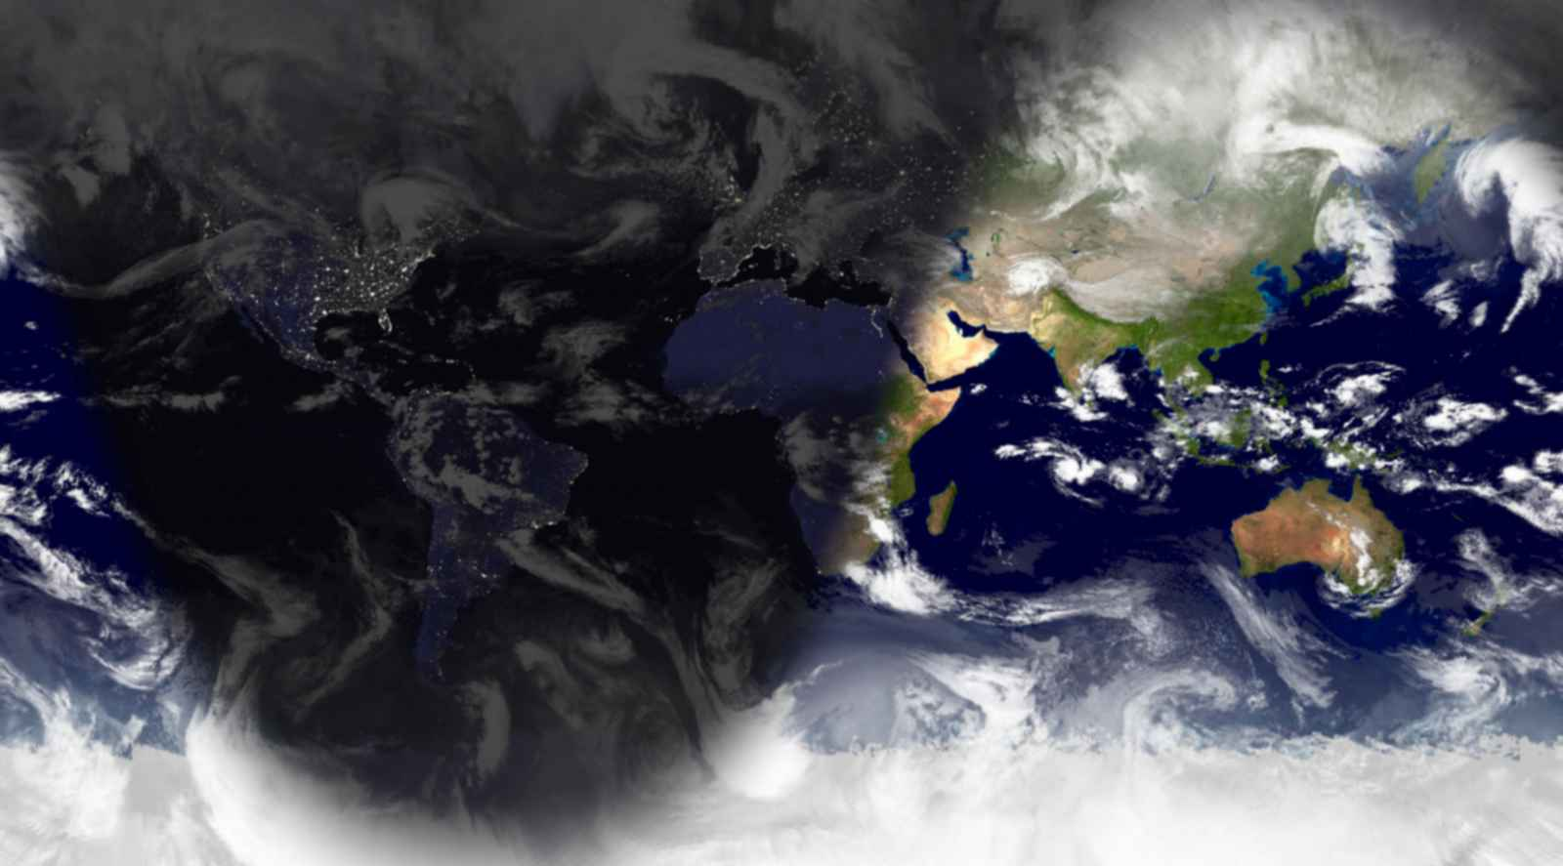

11/9/05, 10:00 P.M. – Sun Observation
The sunlight on the Mercator projection has become very pronounced. At its highest, the sun was only 30 degrees above south at 11:28 a.m.
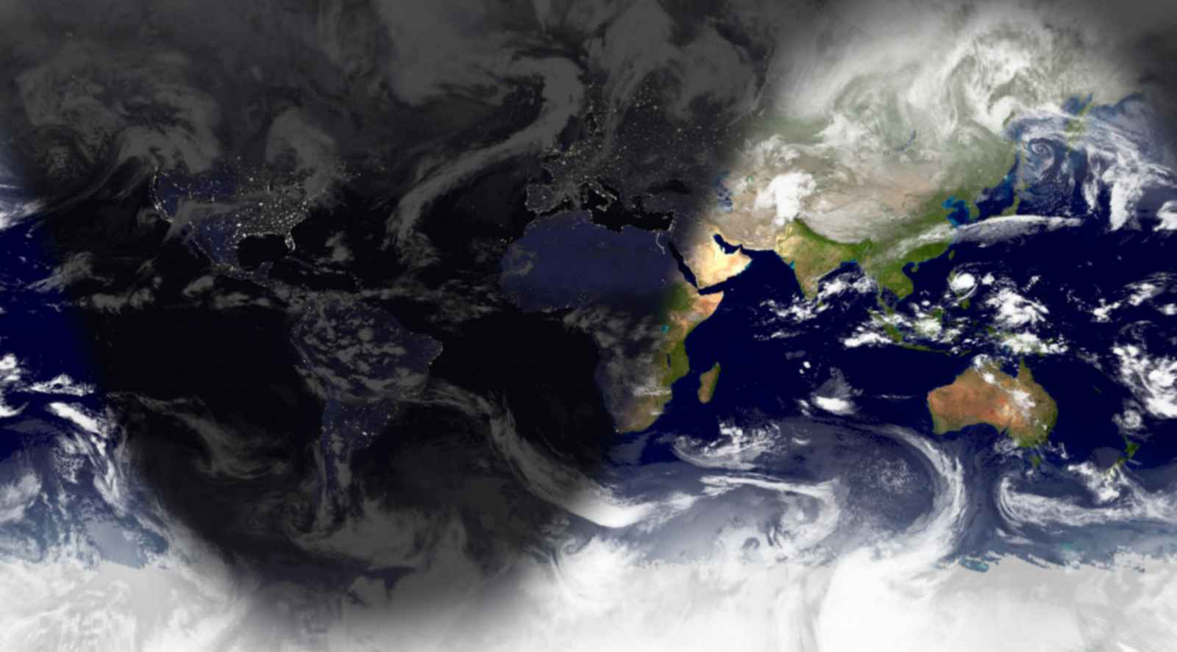

11/13/05, 3:00 P.M. – Pioneers of Space
I told my Spanish professor that I wouldn’t be in class on Friday. Instead, I went to the Museum of Science and explored a bit before the event. My favorite exhibits were the mathematics hall, the Apollo mission replicas and the tamarins.
I was sure to arrive at the auditorium early to get a good seat for Pioneers of Space. I thoroughly enjoyed the event, especially hearing from the Russians. I considered asking Mr. Hoffman a question about the future of the space program and the CEV, but I did not get the chance before time ran out.
After the event Seamus and I found Mike in the Human Body Connections area of the museum and learned about the chemical PTC. The weather was looking good for observing at the Gilliland Observatory, so I had some time to kill. I continued to explore until I experienced the angular momentum exhibit, at which point I needed to sit down for a bit.
Finally, I met Mike at the observatory. I saw Mars, Phobos and Deimos through the telescope, which was really cool. Also, Mike got locked underneath the observatory, which was good for a laugh. It was a great evening.

Today’s Sun Observation: The Sun continues to sink in the sky. Today, it was 29°48' above south at 11:28 p.m. and will set at 4:24 p.m.

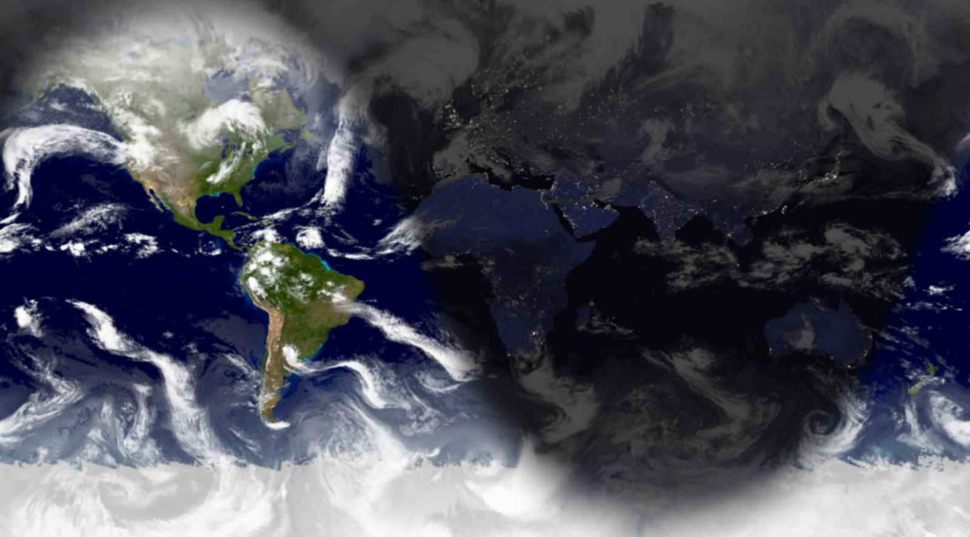

11/17/05, 8:00 P.M. – Sun Observation
It was partly cloudy when transit occurred at 11:29 this morning. The Sun just barely cleared the houses that make up my skyline, topping out at less than 30 degrees (28°31'40" to be exact).

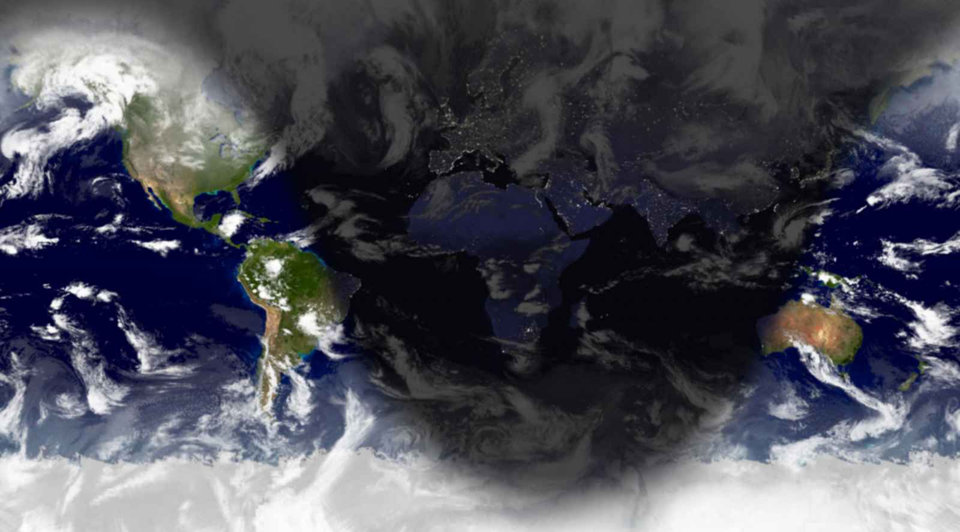

11/19/05, 12:00 P.M. – Solar Telescope
I borrowed the solar telescope to bring into an elementary school next week. I decided to set it up this afternoon for practice. It took me a couple of minutes to find the Sun, but it was pretty amazing when I did. I asked a couple of people walking by if they wanted to see, but they looked at me like I was nuts. Oh, well, their loss.

Today’s Sun Observation: When I looked through the telescope at about noon, the Sun was 27°39' above the horizon just west of south.
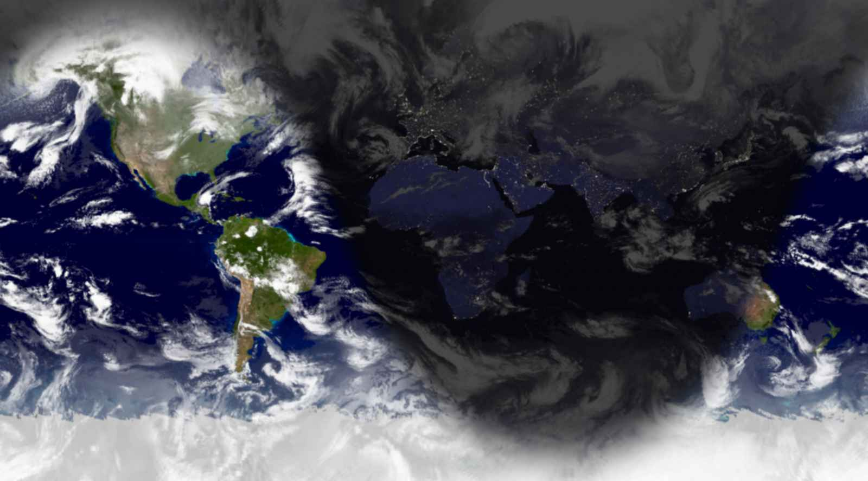

11/22/05, 12:00 P.M. – Solar Telescope
This morning, I brought the telescope to the elementary school and the 4th and 5th graders took a look. They all thought it was really cool, of course. I was able to use their observations as I taught them about the Sun. The kids also got a kick out of the song I played for them, “Why Does the Sun Shine?” by They Might Be Giants.
Later, I told a friend about the experience and she told me about the lady outside of Robinson Hall on Friday that she thought was nuts for looking at the Sun through a telescope.
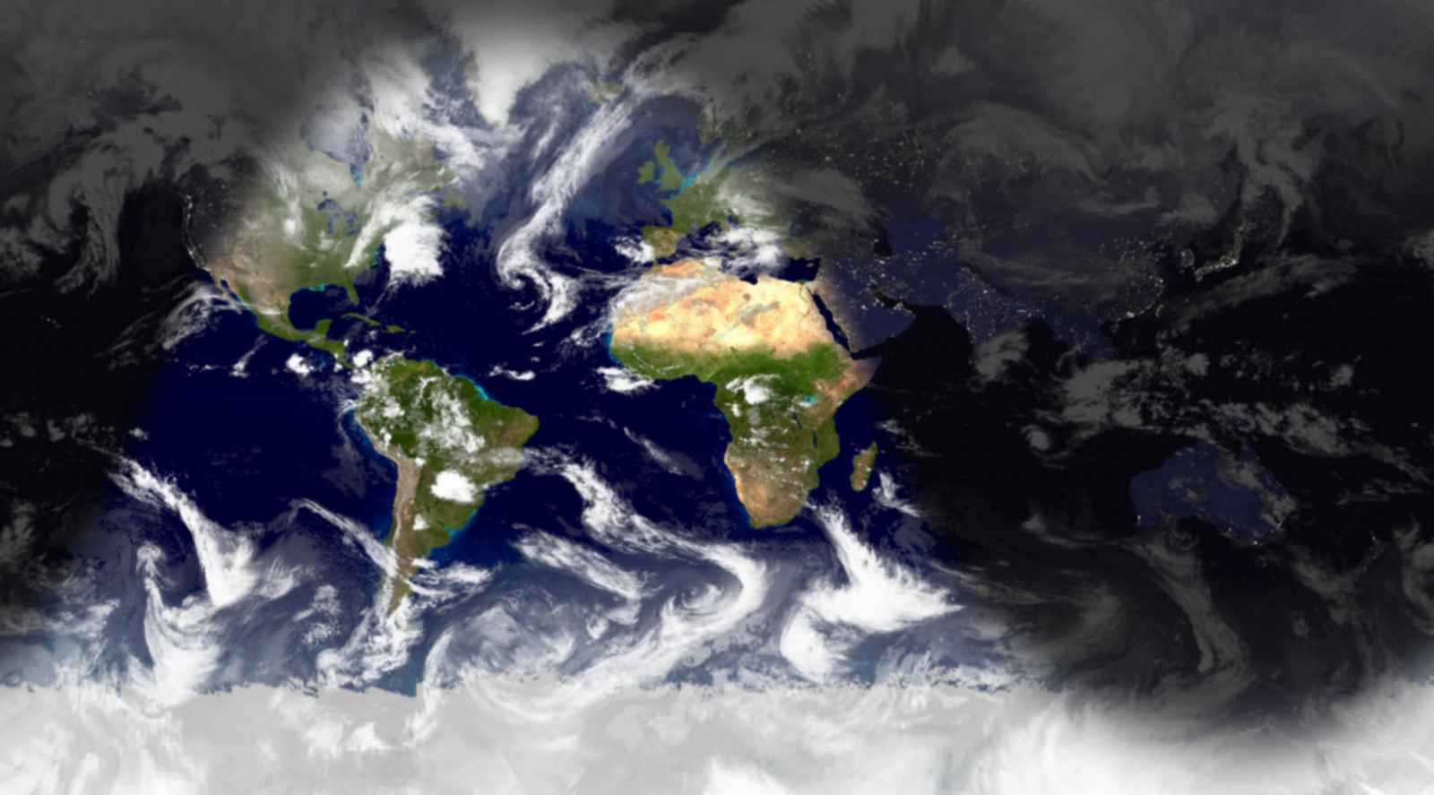

11/27/05, 8:00 P.M. – Southern Sun
I went back to Tampa for Thanksgiving break and enjoyed the chance to back in the Sun. The Sun didn’t rise much above 26 degrees and it set at 4:14 here in Somerville; in Tampa, it was almost 41 degrees in the sky and set at 5:34, a much more reasonable hour. It was very enjoyable.
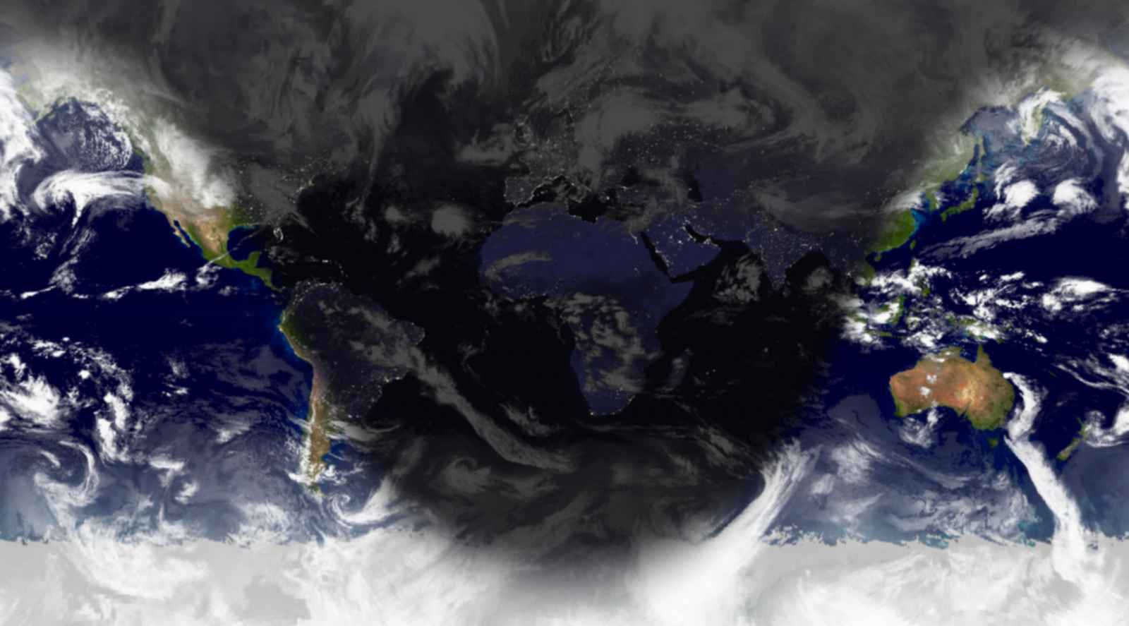

11/29/05, 11:31 A.M. – Sun Observation
Should I have the power to see through clouds, I would see the Sun 26°36'08" above south. But I don’t have that ability, so I guess I’m out of luck.

12/1/05, 2:00 P.M. – Sun Observation
Transit is has been occurring later recently but the Sun continues to appear lowery in the sky. Today transit was at 11:33 and the Sun was 25°45' above South. The Mercator projection is looking pretty nice, though.
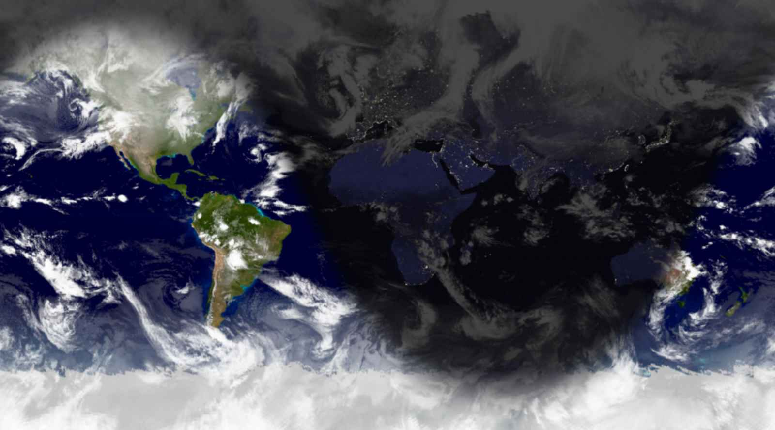
12/4/05, 12:00 P.M. – Sun Observation
Transit: 11:34, Azimuth: 25°20', Weather: Bad
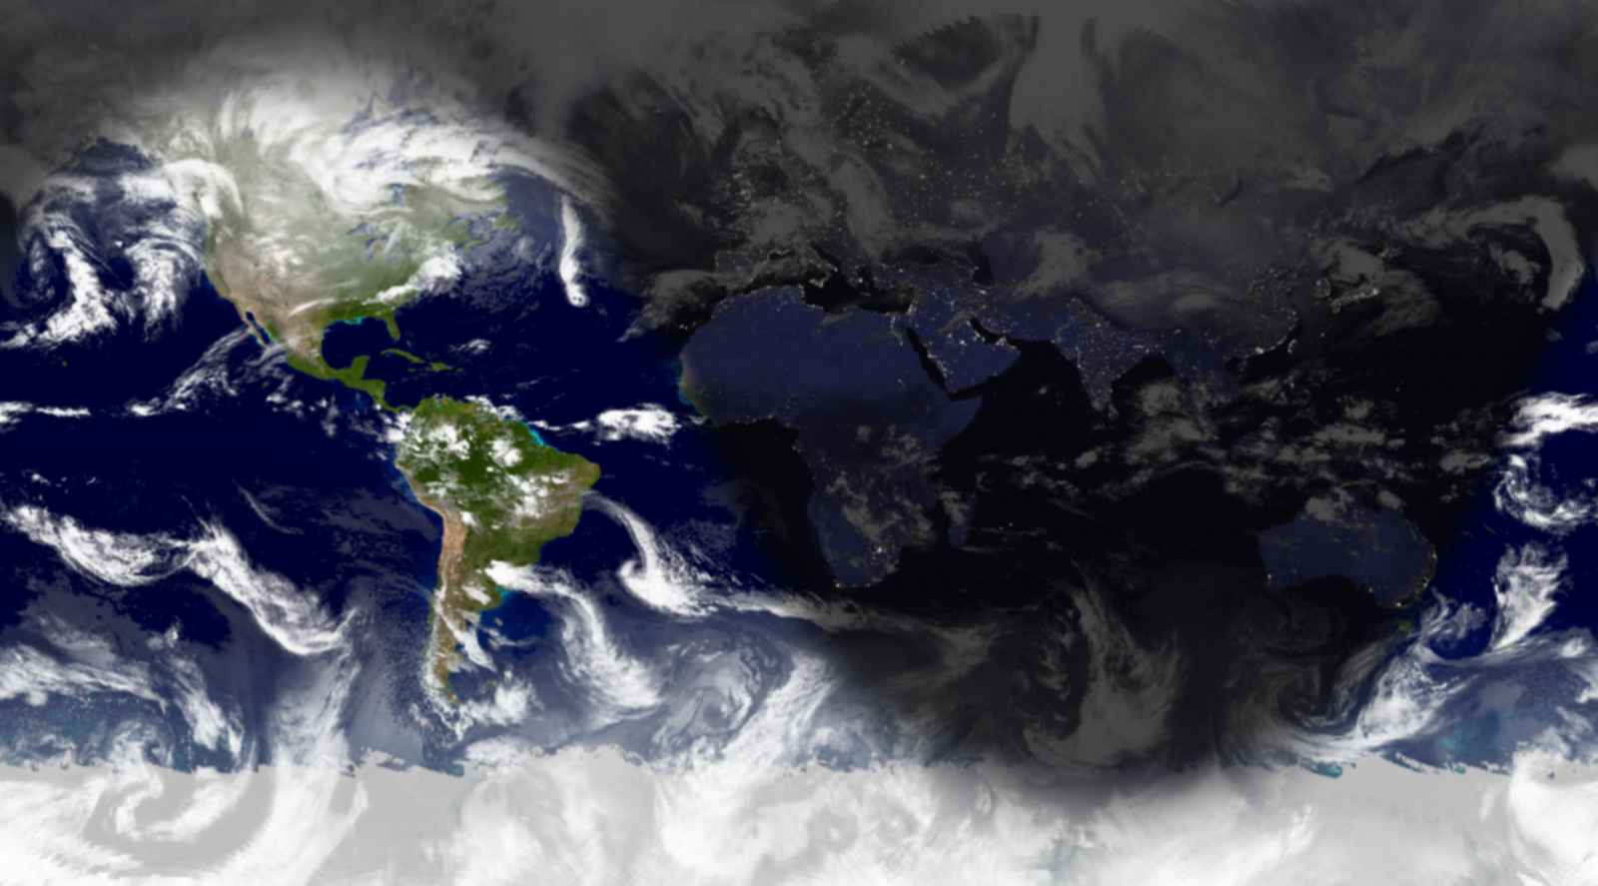

12/8/05, 3:23 P.M. – Good Night and Good Luck
My entries have been getting shorter and shorter as we near the end of the semester and my workload has increased, but I thought I should make my last entry a good one. I have enjoyed this class a great deal but I have also learned a lot. Combined with my other science education class, I have had a wonderful experience that neither of the classes individually could have delivered. This class involved a lot more work than I had initially imagined, but I think it was all worth it.
I don’t know what else to say, so I guess I’ll just give a Sun observation. As I was walking back from Economics class this morning, I felt the Sun’s warming rays (just barely) coming from about 25 degrees above the south horizon.
